**Ways people show stress**

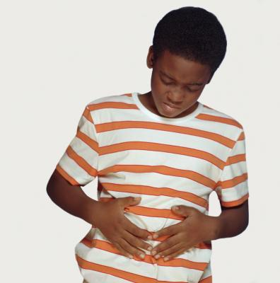 [](http://thumbs.dreamstime.com/z/headache-11533613.jpg)

**STOMACH ACHE** **HEAD ACHE**

[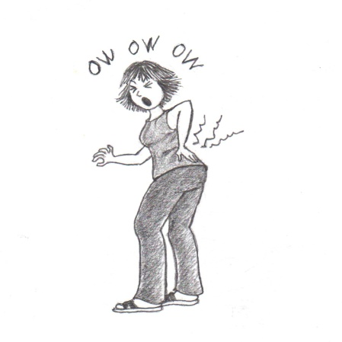](https://s-media-cache-ak0.pinimg.com/originals/21/7a/85/217a854694d94317b464adb62879b5bd.jpg) [](http://www.google.com/url?url=http://karlilopez.hot1035radio.com/tag/arguing/&rct=j&frm=1&q=&esrc=s&sa=U&ei=jFlCVdDcMorEggSe3YH4Aw&ved=0CBYQ9QEwAA&usg=AFQjCNHGCBtnzSt254aZwldx1A99MCXkwQ)

**BACK ACHE**  **ARGUING**

[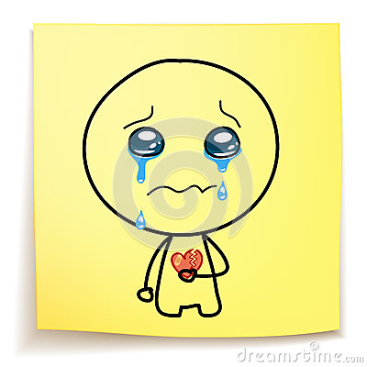](http://thumbs.dreamstime.com/z/hand-drawn-cartoon-crying-broken-heart-sticky-notes-31857736.jpg) **CRYING 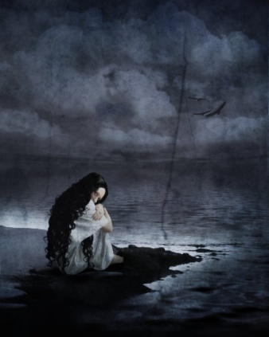 ALONE**

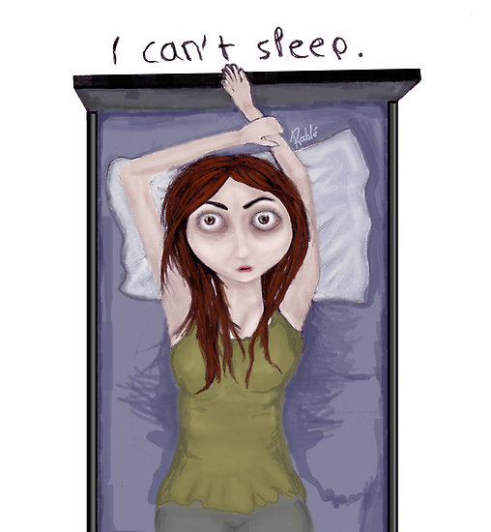 [](http://www.google.com/url?url=http://www.businessinsider.com.au/income-inequality-is-making-women-more-depressed-2013-11&rct=j&frm=1&q=&esrc=s&sa=U&ei=51pCVYCuB4OUNr-pgXA&ved=0CB4Q9QEwBA&usg=AFQjCNHvd0_JelKap9f1c9c1xXk_we5Ncg) **NOT SLEEPING**  **FEELING SAD**

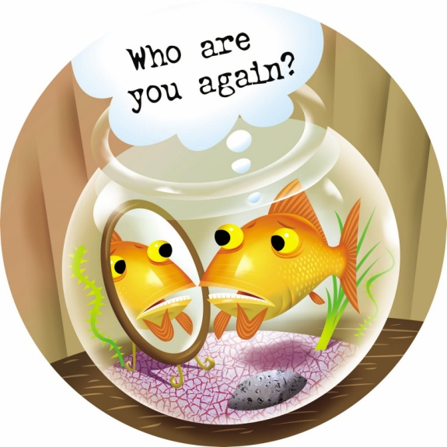 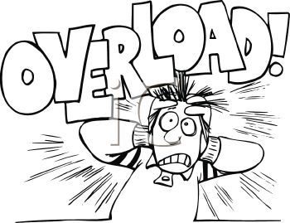

**FORGETTING A LOT**  **CAN’T STOP THINKING**

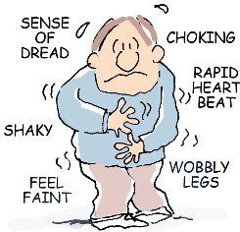 

**WORRYING/ANXIETY** **SPENDING MONEY**

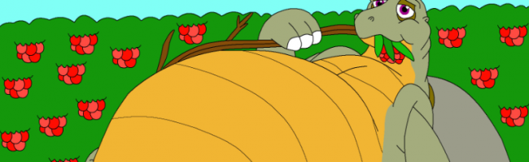

**EATING TOO MUCH**

[](http://www.google.com/url?url=http://www.elephantjournal.com/2010/10/hopelessness-its-a-good-thing-eve-eliot/&rct=j&frm=1&q=&esrc=s&sa=U&ei=7lxCVeftPIaZNsj9gMAB&ved=0CDAQ9QEwDQ&usg=AFQjCNHeYftVWecZsKJhycAb2WsTGFeBWw) [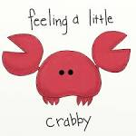](https://www.google.com/url?url=https://imthelittlemissfit.wordpress.com/2013/11/14/day-six-love-is-not-irritable/&rct=j&frm=1&q=&esrc=s&sa=U&ei=b11CVeSGCMeYNs-pgMAM&ved=0CBYQ9QEwAA&usg=AFQjCNFShQChyik_2MGg-BhrNEaZcb-M9g)

**HOPELESSNESS** **ANNOYED/IRRITATED**

 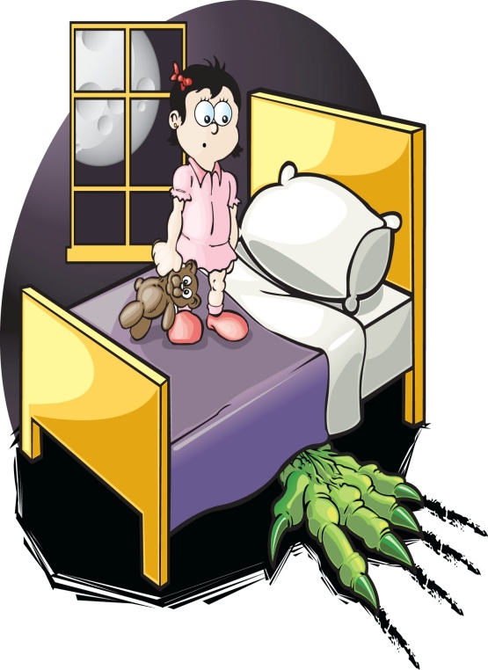

**DRINKING ALCOHOL/ BAD DREAMS**

**USING DRUGS**