**Things that can cause stress**

[](http://www.google.com/url?url=http://www.gabankruptcylawyersnetwork.com/2014/05/what-state-exemptions-apply-if-i-just-moved/&rct=j&frm=1&q=&esrc=s&sa=U&ei=e0RCVYL_H4m_ggTUjoTgDg&ved=0CDIQ9QEwDg&usg=AFQjCNH8KlBazIjeoBf8b-9RysQ2TS973Q) 

**MOVING** **LITTLE MONEY AND MANY BILLS**

[](http://allnationsdurham.com/wp-content/uploads/2011/09/kids.jpg)[](http://www.binoandfino.com/)

**CHILDREN** **FAMILY**

 

HEALTH WORRIES

**[](http://www.iforidiot.com/wp-content/uploads/2014/11/gm.jpg)**

LANGUAGE

[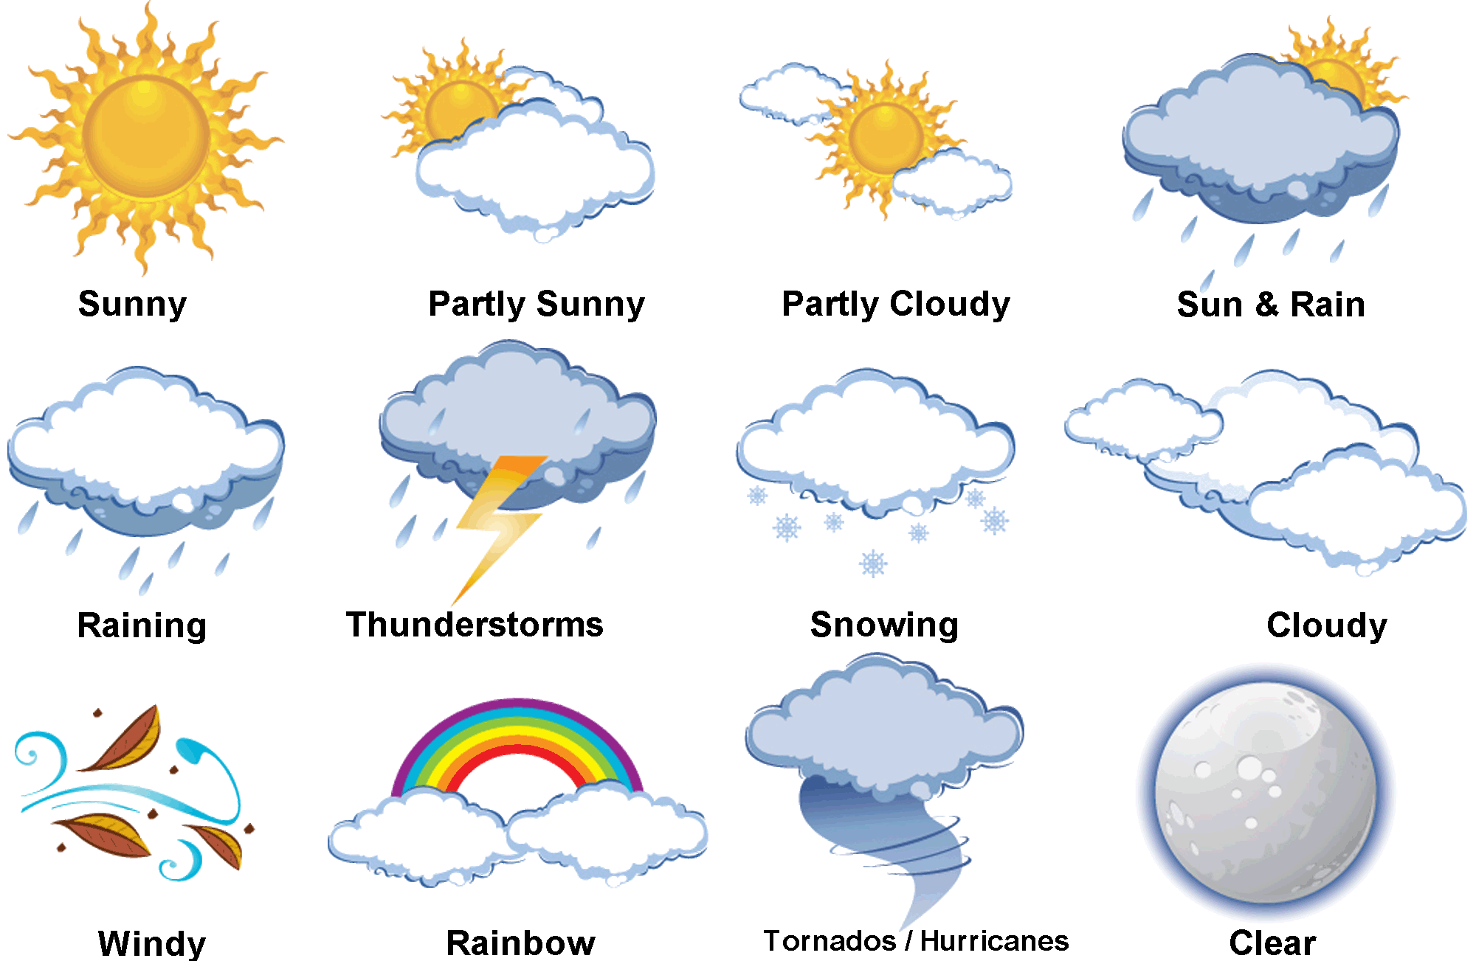](http://dreamatico.com/data_images/weather/weather-7.jpg) [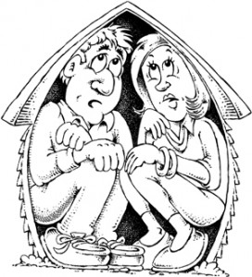](http://preparednesspro.com/wp-content/uploads/2012/04/crowded-house.jpg)

WEATHER HOUSING