**Ways to relieve stress**

[](http://www.google.com/url?url=http://scienceillustrated.com.au/blog/culture/the-evolution-of-music/&rct=j&frm=1&q=&esrc=s&sa=U&ei=6RpCVY2cNcadgwSJ9ICYAw&ved=0CDwQ9QEwEw&usg=AFQjCNG-43qyDwV8A3C5kgLf-ZG2kgOEXw) [](http://www.google.com/url?url=http://ashevilleperformingartsacademy.com/&rct=j&frm=1&q=&esrc=s&sa=U&ei=XBtCVcTgPMawggSL0IGADA&ved=0CDoQ9QEwEg&usg=AFQjCNEoGgYWyz6QDslL64OA-4SV9h33vg)

**MUSIC**  **DANCE**

[](http://www.google.com/url?url=http://www.dreamstime.com/photos-images/big-laugh.html&rct=j&frm=1&q=&esrc=s&sa=U&ei=0xtCVbSlEcOpNt-_gagP&ved=0CCYQ9QEwCDgU&usg=AFQjCNHEf_GrnjjawC_GRRjP4D6Ob2orTg) [](http://www.google.com/url?url=http://300stories.com/blog/healthy-talk&rct=j&frm=1&q=&esrc=s&sa=U&ei=ExxCVZKbJ8euggTr5ICQDA&ved=0CDQQ9QEwDzgU&usg=AFQjCNH6RdGA4U0sj9YV5tbs0TGbVYhRhA)

**LAUGH**  **TALKING**

[](http://www.google.com/url?url=http://www.agsd.org.uk/tabid/1942/default.aspx&rct=j&frm=1&q=&esrc=s&sa=U&ei=aBxCVb2PMYH_gwT3-4DADg&ved=0CBwQ9QEwAzgo&usg=AFQjCNEUUb5qdYWflMd_rUKaFZ1OoE2Fow) [](http://www.google.com/url?url=http://animalshugging.tumblr.com/post/4818424833/hug-oclock&rct=j&frm=1&q=&esrc=s&sa=U&ei=nBxCVae6L4GJgwSh-IGwDg&ved=0CDYQ9QEwEA&usg=AFQjCNGKE6c01WOLdVxo_3y_V_6UjsX-Bg)

**WALK**  **HUG**

[](http://www.clipartpanda.com/clipart_images/sing-clipart-image-clip-art-5320759) 

**SING**   **PRAY**

[](http://paintcutpaste.com/wp-content/uploads/2011/05/artforkids-brushes2.jpg) [](http://www.clipartpanda.com/clipart_images/cooking-clipart-item-2-vector-10130833)

**PAINT/COLOR/DRAW**   **COOK**



**CRY**

[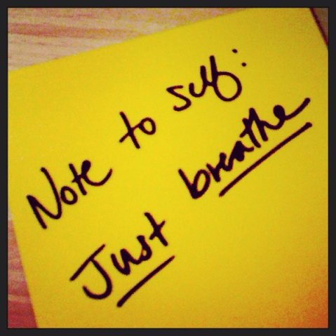](https://s-media-cache-ak0.pinimg.com/originals/73/73/6c/73736c21fec04207f982ad85199b220d.jpg) **BREATHE**

[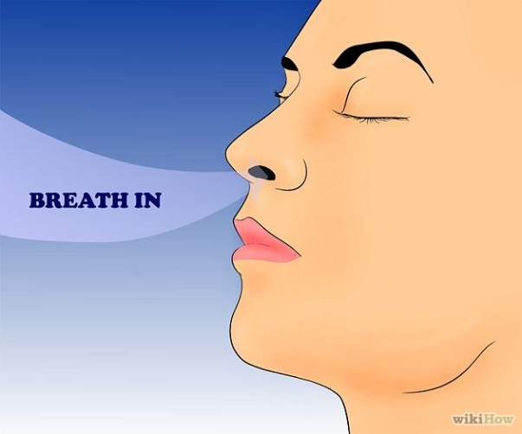](http://www.wikihow.com/Breathe#/Image:Breathe-Step-2-Version-3.jpg) [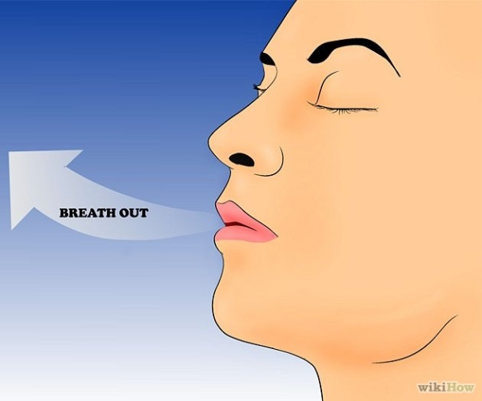](http://www.wikihow.com/Breathe#/Image:Breathe-Step-3-Version-3.jpg)