**Lifeline**



   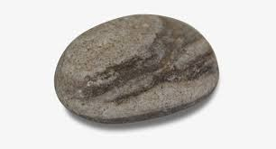  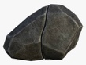

|  |  |  |  |  |  |  |  |  |  |  |  |  |  |  |  |  |  |  |  |  |  |  |  |  |
| --- | --- | --- | --- | --- | --- | --- | --- | --- | --- | --- | --- | --- | --- | --- | --- | --- | --- | --- | --- | --- | --- | --- | --- | --- |
| Lifeline | |  | | --- | | Violet Spring Flower PNG Clipart | Gallery Yopriceville - High ... I was born on June 1st, 1984 in Atlanta, Georgia. My parents went in for their scheduled c-section and I was born a healthy baby. | | Transparent Rock Clipart - Transparent Background Stone Clipart ... 6 yo - My sister and I were in a car accident. I felt fear and thought "What if we die?" | | clipart flower - Clip Art Library 10 yo - We went on vacation to Hawaii with my grandparents. It was a lovely time and we had a lot of fun. | | Pebble Stone Png Picture - Pebble Clipart - 820x615 PNG Download ... 12 yo - My parents told me they are getting a divorce. I felt sad and angry. | | Free Small Flower Clipart, Download Free Clip Art, Free Clip Art ... 13 yo - I have my first kiss with my crush. | |  | |  | |  | |  | |  | |  | |  | |  | |  | |  | |  | |  | |  | |  | |  | |  | |  | |  | |