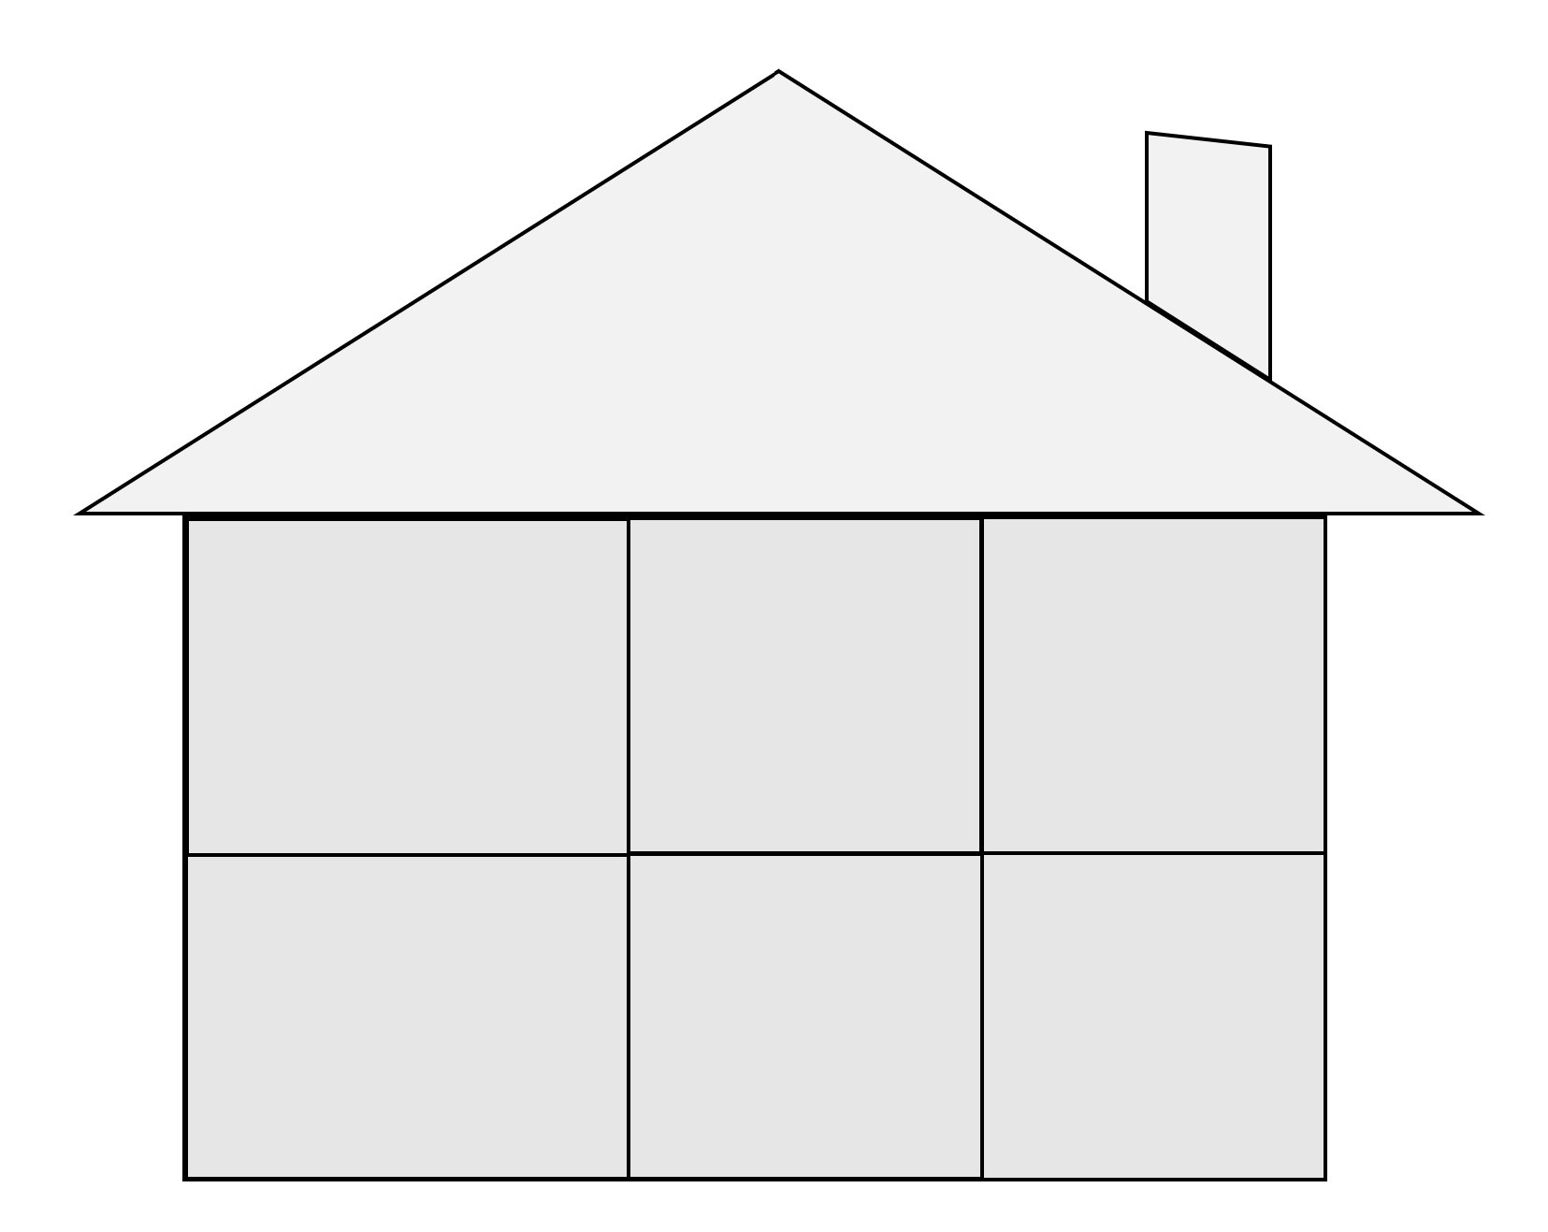
“Where I’m From” House Activity Prompts
1. Three items around your childhood home, one with a brand name
5.Names of foods that recall childhood or family/community gatherings
6.Names of places you keep in your childhood memory that were important to you
4. Sayings remembered from childhood.
Alternative option: family traditions
3. Names of relatives that link you to the past
2.Three items found in your yard, neighborhood, or areas where you would play.
7.Family photos or mementos, keepsakes or things that remind you of the past
I’m From…

